Verification and Testing Report

1. Deliverable Management and Quality Impact

1.1. Preliminary Codebase Examination

a. Dead Code

Initial examination reveals three dead functions; “validate_priority”, “format_task_for_display”, and “calculate_workload”. A comment in “validate_priority” informs the user about this. This suggests that while validation logic was planned for and implemented, it was never integrated, suggesting rushed delivery.

“flask.render_template_string” is imported but never used.

b. Inconsistencies

The codebase contains inconsistent SQL queries. The “login” function uses string formatting in its query:
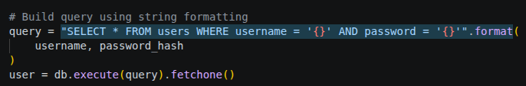
, which is insecure, while the “get_task” function uses context-appropriate parameterised queries:
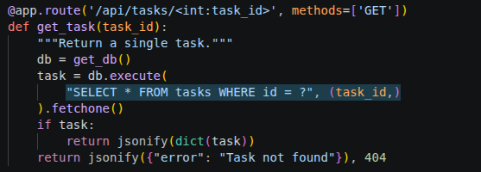

.

One other place where string formatting is being used in place of parameterised queries is the “search_tasks” function.

Input validation inconsistencies were also found. The “create_task” function validates input properly:

, while “update_task” does not:
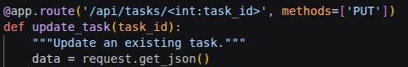

One other example of this is the “add_comment” function, where input is not being validated either.

Error-handling inconsistencies were found as well. Some functions like “get_task” incorporate proper error handling:
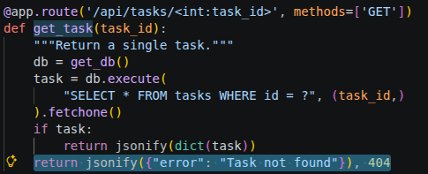

, while

